Contents

**1. Introduction** 2

**1.1 Purpose** 2

**1.2 Scope** 2

**2. System Overview** 2

**2.1 System Architecture** 2

**2.2 Key Features** 2

**3. Functional Design** 3

**3.1 Project Stages** 3

**3.2 Project Management** 3

**3.3 Approval Process** 3

**4. Technical Design** 3

**4.1 Data Management** 3

**4.2 User Interface** 3

**4.3 Approval and Notification System** 4

**4.4 Reporting** 4

**5. Known Issues and Improvement Areas** 4

**5.1 Multi-Threading Issues** 4

**5.2 Error Management** 4

**6. Code and Documentation** 4

**6.1 Core Functionality** 4

**6.2 Documentation** 4

**7. Conclusion** 5

**1. Introduction**

**1.1 Purpose**

The purpose of this document is to provide a comprehensive technical design for the Risk Assessment and Management Application. This application is designed to identify and assess potential hazards and risks throughout the project lifecycle, ensuring safety from initial concept through to project completion.

**1.2 Scope**

The application supports capital projects across various domains, managing risk assessments through defined project stages and integrating approval processes. It includes features for risk identification, stakeholder approval, notifications, and reporting.

**2. System Overview**

**2.1 System Architecture**

The application utilizes SharePoint as the primary data source and PowerApps for user interface development. The system includes:

* **SharePoint Database:** Stores project data, risk assessments, and stakeholder information.
* **PowerApps Interface:** Provides the user interface for managing project stages, approvals, and notifications.

**2.2 Key Features**

* **Project Stages:** Structured stages for risk assessment and approval.
* **Approval Process:** Automated stakeholder notifications and approval management.
* **Reporting:** PDF generation for project summaries and risk status.
* **PRP Summary Screen:** Overview of risk status with color-coded indicators.

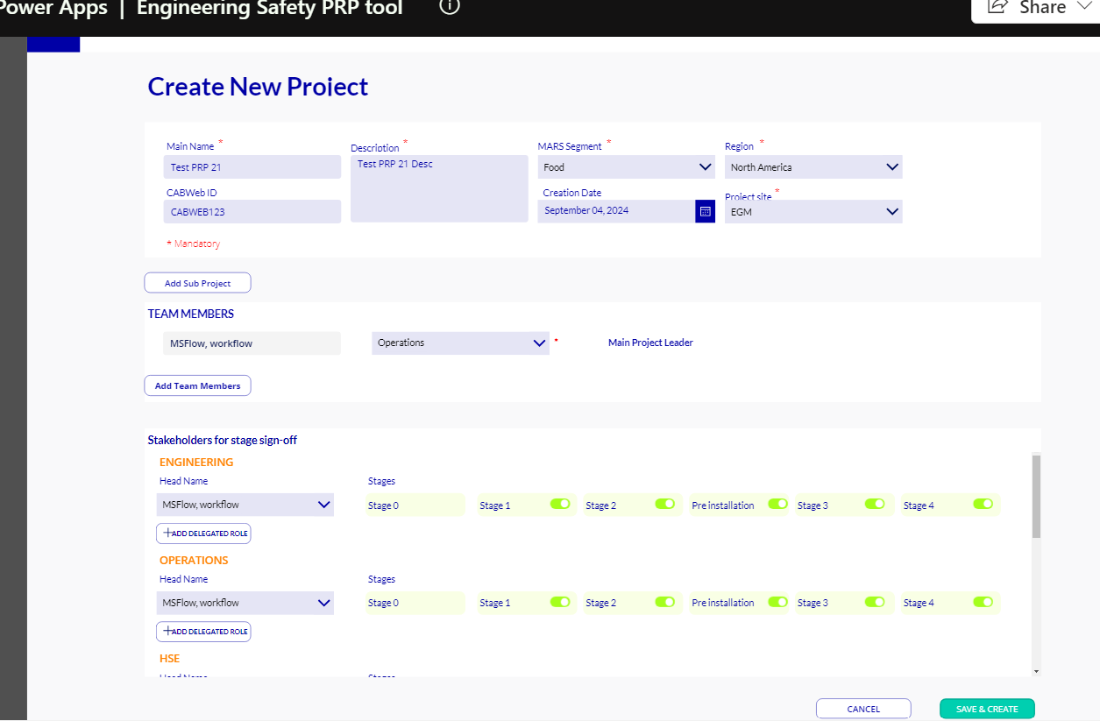

**Project creation screen**

**3. Functional Design**

**3.1 Project Stages**

**3.1.1 Stage 0**

* **Purpose:** Initial risk and license stage for early risk identification.
* **Approval:** No sign-off required.
* **Functionality:** Risk identification and preparation.
* 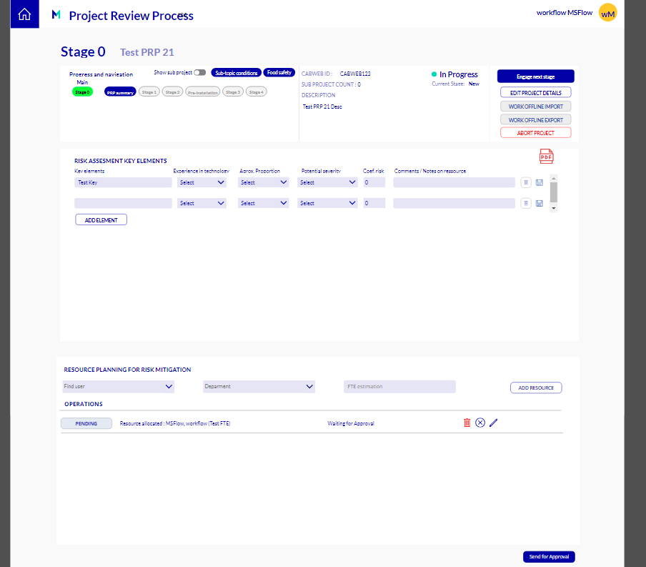

**3.1.2 Stages 1-4**

* **Purpose:** Detailed risk assessment and project approval.
* **Approval:** Requires stakeholder sign-off at each stage.
* **Functionality:** Consistent process and format for risk evaluation and approval.

Please check below stage 1 and stage 2 for reference, similar to stage 3 and stage4.

* A screenshot of a computer

  Description automatically generated
* 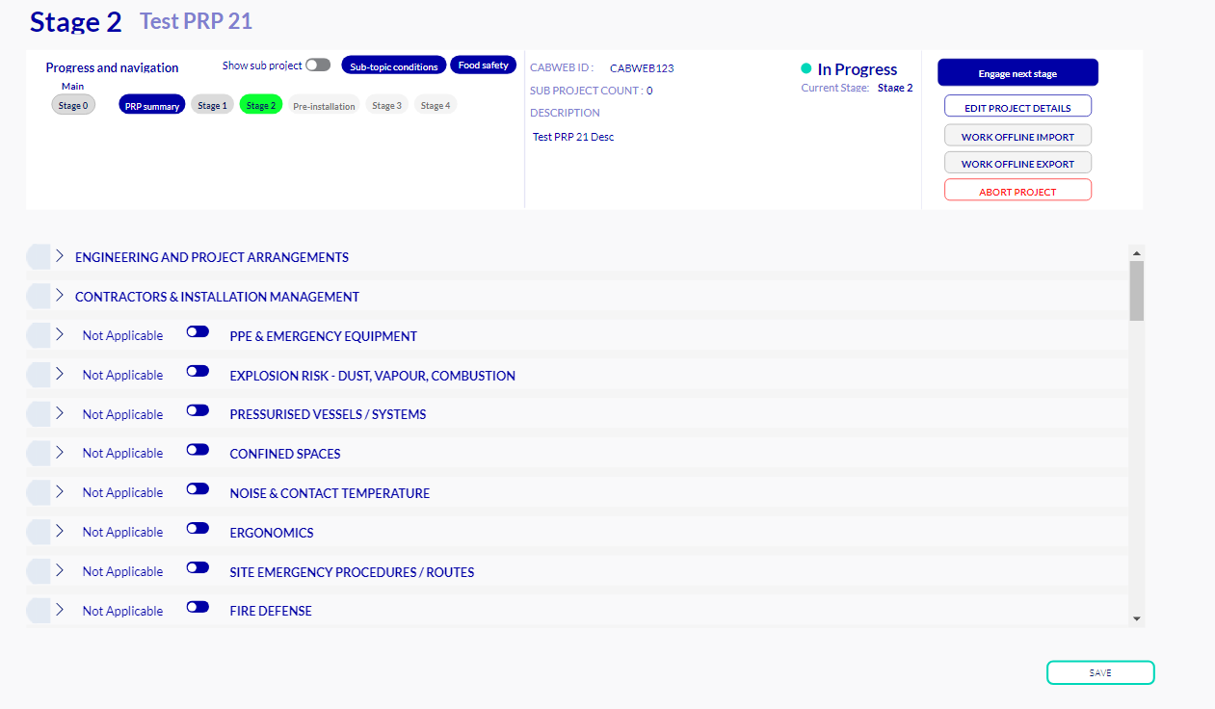

Once you fill the mandatory details and save then it will be saved to stage2PRPsumary SP list, and it is similar for other Stages also.

After entered all the details from each stage, from the PRP Summary screen section click on start approval -> once clicked stakeholder will be received notification for approval and once approved it becomes signoff for each stage. We can not edit the project details anymore after signoff

Check below image for the reference.

**3.1.3 Pre-Installation Stage**

* **Purpose:** Specific to onsite installation work.
* **Approval:** Separate sign-off process.
* **Functionality:** Manage installation-specific risks and approvals.

Please check below Pre-Installation stage image for reference

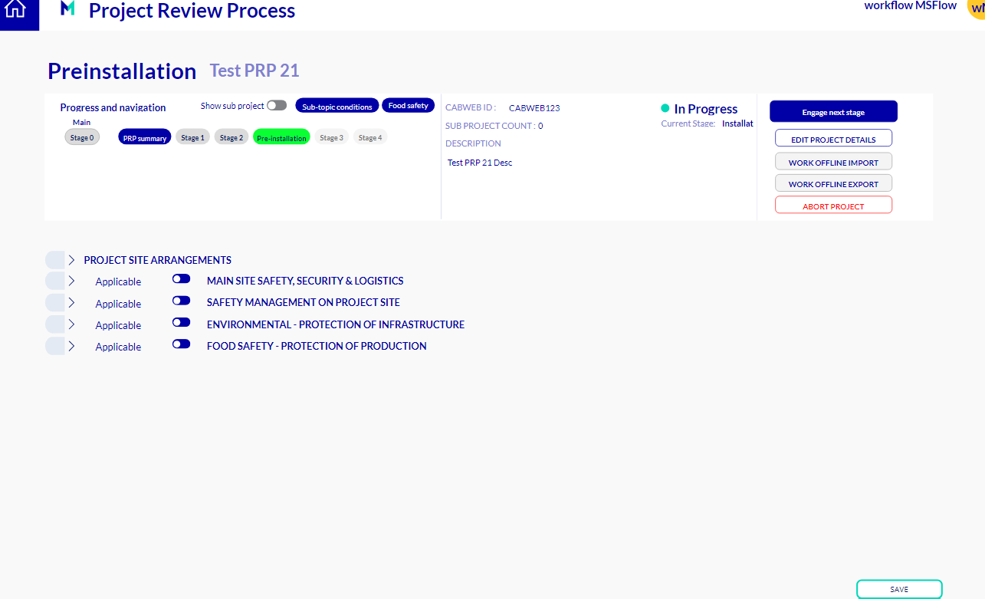

**3.2 Project Management**

* **Sub-Projects:** Ability to divide complex projects into manageable sub-projects.
* **Stakeholder Management:** Define and assign roles and responsibilities for each stage.

**3.3 Approval Process**

* **Approval Requirements:** Mandatory approval from Stage 1 onwards.
* **Visibility Control:** Toggle button to manage visibility of approval options.
* **Notifications:** Automated email alerts for stakeholder review and approval.
* **Stage Management:** Options to abort (delete) or archive projects at different stages.

**4. Technical Design**

**4.1 Data Management**

* **Data Source:** SharePoint
  + **Tables:** Projects, Risk Assessments, Stakeholders, Approvals
  + **Relationships:** Projects linked to Risk Assessments and Stakeholders

**4.2 User Interface**

* **PowerApps Components:**
  + **Forms:** For data entry and risk assessment.
  + **Dashboards:** PRP Summary Screen for risk status overview.
  + **Approval Screens:** For managing stakeholder approvals.

**4.3 Approval and Notification System**

* **Approval Workflow:** Stage-based approval system with email notifications.
* **Conditions:** Stakeholders can specify conditions that must be met before proceeding to the next stage.
* 
* 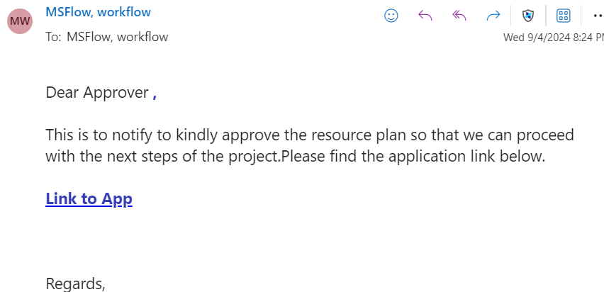

**4.4 Reporting**

* **PDF Generation:** Functionality to generate and email PDFs summarizing project details and status.

**5. Known Issues and Improvement Areas**

**5.1 Multi-Threading Issues**

* **Problem:** Handling multi-threading within PowerApps, particularly under network constraints.
* **Improvement:** Enhance performance and reliability of concurrent operations.

**5.2 Error Management**

* **Problem:** Handling fast-paced changes and error management challenges.
* **Improvement:** Develop robust error handling and management strategies.

**6. Code and Documentation**

**6.1 Core Functionality**

* **Approvals:** Code for managing approvals and stakeholder notifications.
* **Data Management:** Logic for handling data entries and updates.
* **Validation:** Patching and validation logic for form inputs and processes.

**6.2 Documentation**

* **Availability:** Documentation provided through the client.
* **Support:** Further code walkthroughs and technical support can be arranged as needed.

**7. Conclusion**

This technical design document outlines the structure, functionality, and technical details of the Risk Assessment and Management Application. It is intended to guide development, implementation, and future enhancements of the application.